**Registration Process**

To register with the FireFlink platform, visit <https://www.fireflink.com>

**Registration Process**

**Follow these steps to register with the FireFlink application**

* Click on the **Start a Free Trail** button. The user will then be taken to the “Create an Account” page.



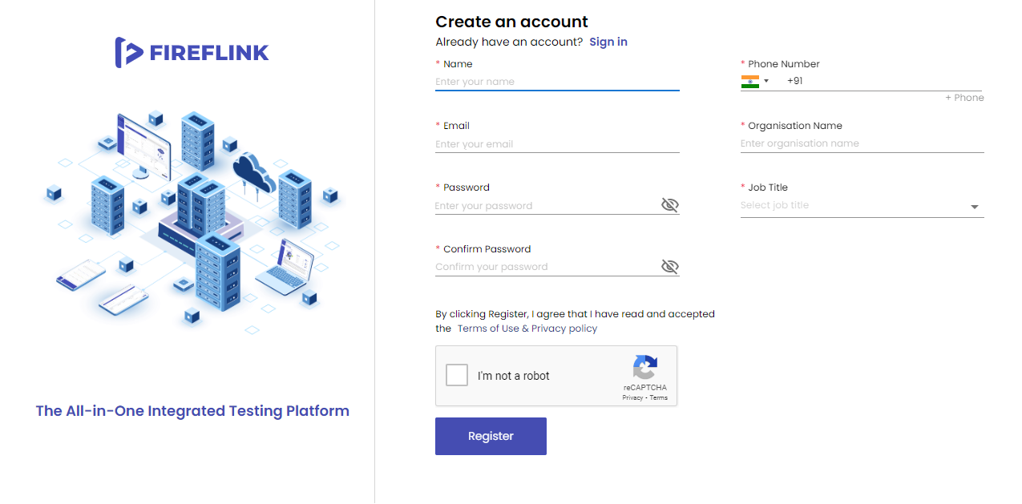

**Enter the data into the mandatory text fields**

* Enter your **Name** in the Name text field which accepts 25 characters.
* Enter your valid **Email ID** in the Email ID Text field.
* Enter the **Password** which should contain characters between 8 to 20 characters which should contain at least 1 Upper case character, 1 Lower case character, 1 digit, and 1 special character in the password Text field.
* Enter the **same password** in the **Confirm Password** Text field.
* Select your **Country Code** from the country dropdown, and Enter a valid **Phone Number** according to your country standard in the phone Number Text field if you want to add a secondary Phone Number click on the **+ Phone** button provided below the Phone Number Text Field and add your **secondary** Phone Number (Not Mandatory).
* Mention your Organization Name in the **Organization** text field.
* Select your **Job Title** from the **Job Title** dropdown.
* Click on the **Register** button.
* You will be navigated to get the “**Registration Successful**” page.

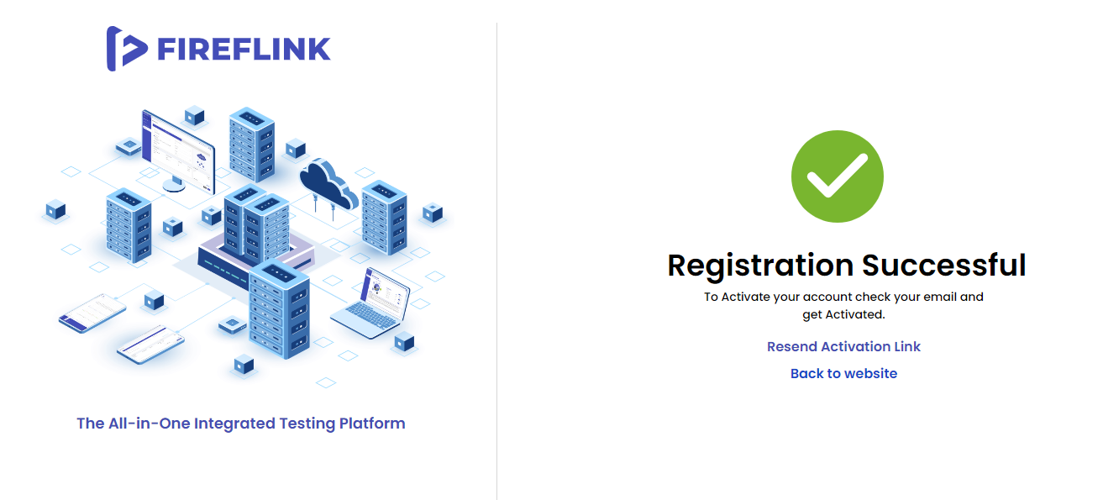

* Upon clicking on **Resend Activation** Link, a new activation link will be sent to your email id.
* Upon clicking on the **Back to website** Link, you will be navigated back to the FireFlink website.

**To activate your FireFlink registration, go to the inbox of the registered email-id**

* You will receive an **Activation Link** to your email after a successful registration. 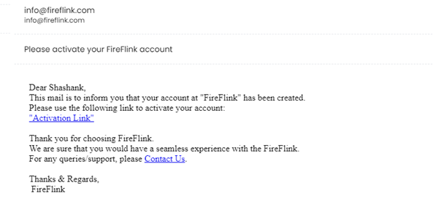
* Click on the **Activation Link** and you will be redirected to the **Verification Code** page.
* At the same time, you will get an **OTP** to your registered primary phone number. Enter that OTP on the Verification Code page.

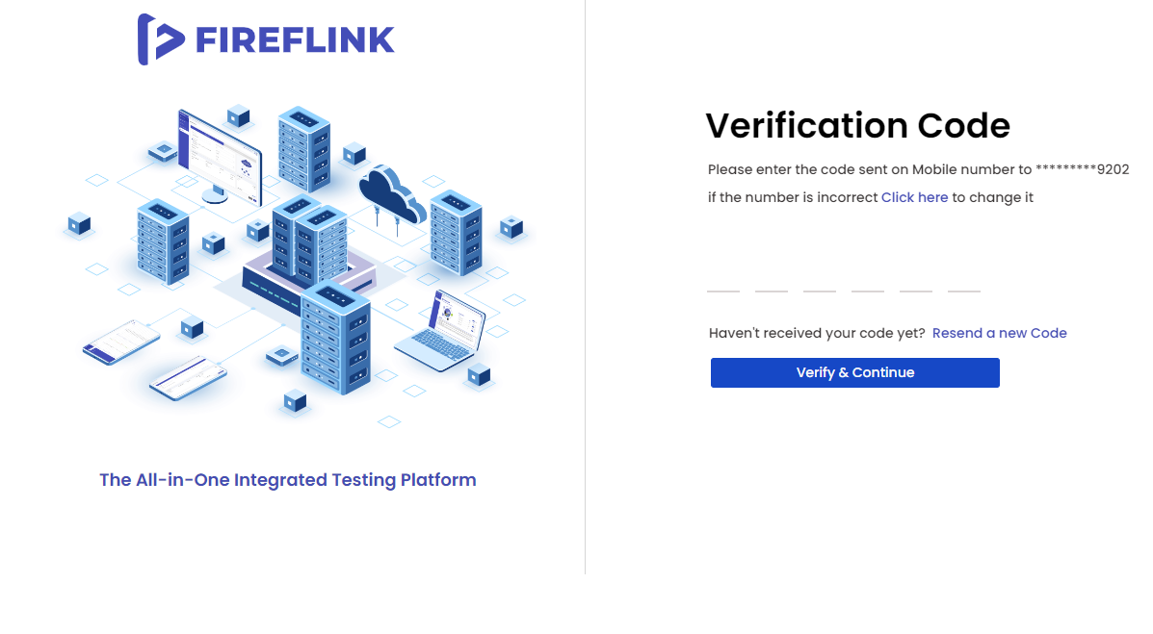

* Click on the Verify **& Continue** button.
* The user has now successfully activated their account with FireFlink. Simply click on the **Proceed to Sign-in** link, and input the registered credentials.

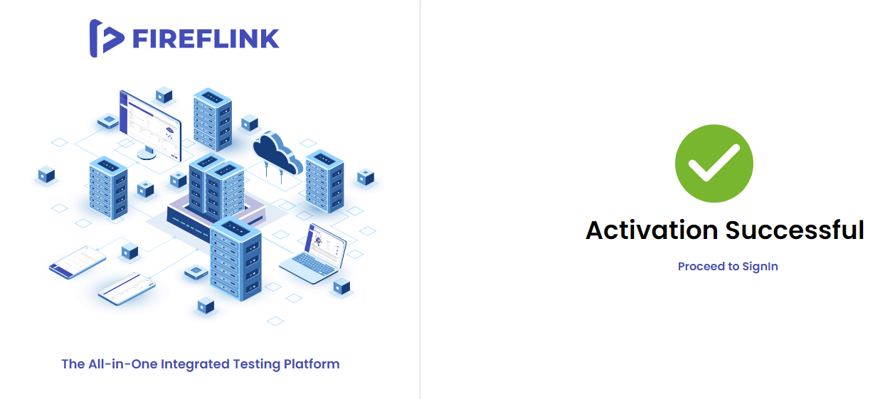

**Account activation process**

* If a user's account remains unactivated even after signing in, they will receive a warning message. This message serves as a notification that their account is still inactive and may provide further instructions or information on how to activate their account. The warning message is intended to inform the user about the status of their account and prompt them to take any necessary actions to activate it.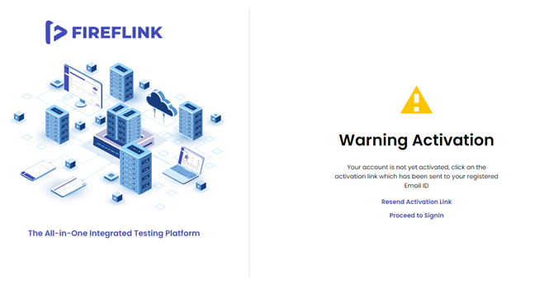
* Click on Resend Activation Link.
* The user will get the '**Activation link sent successfully**' message on the **Warning Activation** page.
* At the same time, you will receive an Activation Link sent to your registered email id. By clicking on the Activation Link, you will be redirected to the Verification Code page.
* Simultaneously, you will receive an OTP to your registered primary phone number. Enter that OTP on the Verification Code page.
* Click on the Verify & Continue button.
* You will land on the **Sign-in** page.
* Now, the user will get FireFlink account activation mail.